Hi Michael,

Thanks for your reply, and sorry for my late reply.

I have advised that our model only works with annual CFs so they will need to convert quarterly to annual cashflows and provide quarterly updates for the fund to take into account the quarterly payments. I did not know we could change the timing of cashflows to mid-year, but I think it is best to keep payments at year-end, so Risk and ALM are consistent with the asset valuation methodology.

In the attached Excel file, you can see the conversion of cashflows:

inflow due to interest accrual of 6% (of the remaining balance, paid quarterly)

And fixed outflow of 8% of the initial principal of the fund (4*20$ per year for 1000 principal)

I have modeled the net cashflow of the fund (as buy and hold, with Floating cash based on the following from the user guide, in case there is a mismatch between IVM and Real MV).

So effectively, the net cash flow from this fund is realized over time (the market value and the duration of the fund become smaller and shorter).

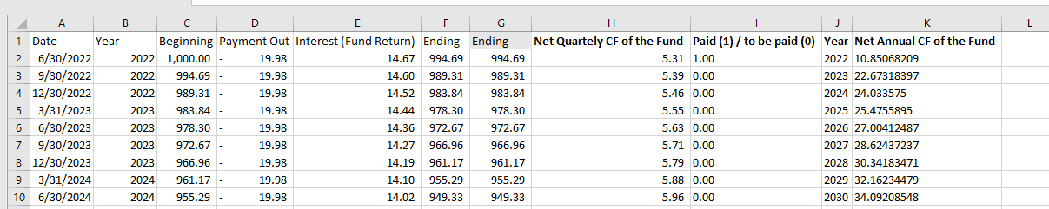

However, it seems that what they want is to model the Payment Out cashflow such that this payout is invested in the target asset allocation. Is this doable? I don’t think so.

**SUMMARY**

